**Software Testing (Report) -**  There should be clear evidence of a logical approach to both user and functional testing. Minimal errors should occur during the typical use of this software

When creating the UI for the software, the only part I could actually get the UI to work on was the web browser, the web browser has a minimalistic look to it with the Address Bar running across the top of the screen, and after typing in the URL the web page will show up in the space under the address bar.

I was unable to get the UI working for the maths or the text box to work as it caused many errors that I was unable to figure out how to fix.

If I had more time I would improve the UI by adding some colour, so that the audience isn’t just staring at a white screen. I would also get the UI working for the maths and text and have a bit of colour added into that.

I would add the colour as the audience is keystage 1 and young children have short attention spans and if something is dull and not very exciting, it will not hold their attention for very long, whereas if something is brightly coloured then it may keep the child’s attention for a bit longer.

When testing I do not have any errors that show in the ‘problems’ area, I do however have 11 warnings. These are:

* Build path specifies execution environment JavaSE-14. There are no JREs installed in the workspace that are strictly compatible with this environment. ( I had this warning for the Maths programme and the Web browser.)
* Resource leak: 'in' is never closed (For the maths programme)
* Resource leak: 's' is never closed (For the maths programme)
* Resource leak: 'sc' is never closed (For the writing programme)
* The import java.awt.BorderLayout is never used (For the writing programme)
* The import javax.swing.JScrollPane is never used (For the writing programme)
* The value of the local variable Base is not used (For the maths programme)
* The value of the local variable c is not used (For the writing programme)
* The value of the local variable v is not used (For the writing programme)
* The value of the local variable w is not used (For the writing programme)

Some of these warnings if I remove creates errors that I could not figure out how to fix.

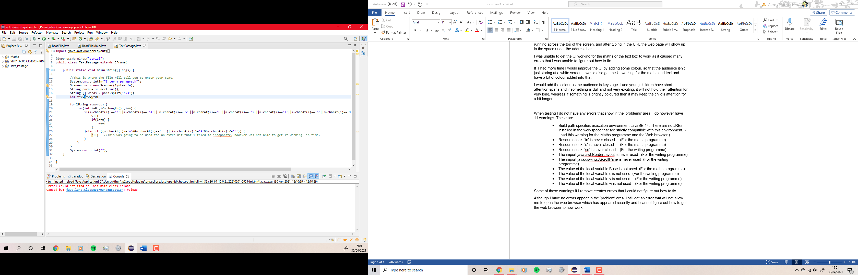Although I have no errors appear in the ‘problem’ area. I still get an error that will not allow me to open the web browser which has appeared recently, and I cannot figure out how to get the web browser to now work.

Before I had this error with the web browser I had tried multiple websites to see if they worked, such as: Google, Bing, Facebook and Twitter. All of which worked at the time.

In the text programme I have extra coding that was not actually needed from something else that tried to incorporate, but it created more errors that I did not have time to try and fix, so I just left them in as they only showed up as warnings but do not stop the programme from working.